Introduction:

The project’s purpose is to analyze the flight activities of some airline companies and their frequent flyers.

**Dimensional Modeling Process:**

1. Business process:

Analyze the flight activities related to marketing and finances departments and customer care services.

1. Granularity:

Per reservation.  
  
**NOTE:** customer care contains transactions that can be committed before any reservation processes like making an interaction before the flight reservation. In this case and for this business process, the granularity will be per each interaction.

1. Dimensions:
2. Passenger Dimension.
3. Flight Dimension.
4. Date Dimension.
5. Class Dimension.
6. Reservation Channel Dimension.
7. Fare Base Dimension.
8. Hotel Dimension.
9. Interaction Dimension.
10. Customer Services Dimension.
11. Facts:
12. Reservation Fact.
13. Transit Hotel Fact.
14. Customer Care Fact.

Project Processes:

Schema Type:

**Galaxy Schema:** The business process required more than one fact table to represent different processes.

Process Diagram:

Using Kimball’s Philosophy.



There will be one row in each fact table for each different transaction collected from passengers. The dimensionality associated with this data is quite extensive. We used the role-playing technique as the date dimension table was used more than one time in the facts table as different dates.

Logical Model:

Represents the facts and dimensions tables, and the relations between them.

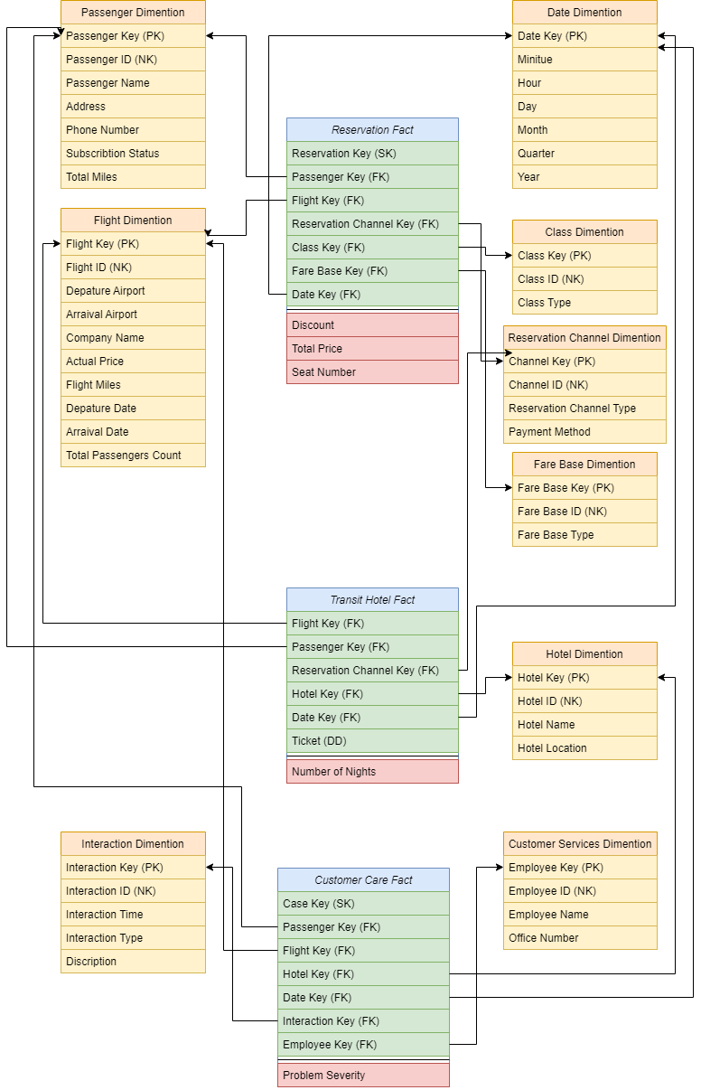

Tables Identifications:

1. Passenger Dimension.

Represents data about passengers, like name, id, address, and phone number. In addition to their subscription type: **GOLD**, **PLATINUM**, or **TITANUM** provide different benefits, and the total miles for each passenger.

1. Flight Dimension.

Represents data about the flight, like flight id, departure airport, arrival airport, airline company name, the miles of the flight, the departure date, the arrival date, and the total number of passengers on this flight.

1. Date Dimension.

Represents the minute, hour, day, month, quarter, and year for each date stored for different business needs.

1. Class Dimension.

Represents the passengers’ reservation class for each flight, it can be **First Class**, **Business Class**, or **Economy Class**.

1. Reservation Channel Dimension.

Represents the channel that the ticket was purchased from it can be **Website**, **Office**, or **Airport**. It also includes the payment method if it was via **Visa**, **Bank**, or **Cash**.

1. Fare Base Dimension.

Represents if the passenger fully paid the ticket price, or with a discount.  
this represents using code numbers which:

**111 means Full Fare First Class.  
112 means Discount Fare First Class.  
221 means Full Fare Business Class.  
222 means Discount Fare Business Class.  
331 means Full Fare Economy Class.  
332 means Discount Fare Economy Class.**

1. Hotel Dimension.

Represents data about the hotels that the passengers stayed on during the transit flights, like hotel name and location.

1. Customer Services Dimension.

Represents data about the customer services employees who are responsible for customer care interactions, like id, name, and office number.

1. Interaction Dimension.

Represents the passenger’s different interactions with customer services, it contains the **Interaction Time** if it was **Before**, **Within**, or **After** the flight, and the **Interaction Type** if it was **Feedback**, **Inquiry**, or **Complaint.**

10 - Reservation Fact.

Represents the reservation processes and the data needed for it, it measures the **Discount** for each passenger based on his subscription:

**10% discount for GOLD subscribers.  
15% discount for PLATINUM subscribers.  
25% discount for TITANIUM subscribers.**

It also measures the **Total Price** after the discount and generates the passenger’s **seat number** after the reservation process is done.

1. Transit Hotel Fact.

Represents the hotel reservation process and the **Number of Nights** that each passenger stayed based on the **arrival time** to the hotel, and the **departure time** from it. Each passenger is assigned to a hotel based on the **Ticket Number**.

1. Customer Care Fact.

Represents the passenger’s different interactions and the customer service employee who was responsible for it. It measures the Problem Severity based on its type and time to work on different interactions based on its priorities. It represents like:

**1 for Complaint Within the flight.  
2 for Complaint Before the flight.  
3 for Complaint After the flight.  
4 for Inquiry Within the flight.  
5 for Feedback Within the flight.  
6 for Inquiry Before the flight.  
7 for Feedback Before the flight.  
8 for Feedback After the flight.  
9 for Inquiry After the flight.**

Assumptions:

1. We compute the frequent flyers based on the number of miles that are assigned to their profiles.
2. We assume that each passenger has a different subscription: **GOLD, PLATINUM,** or **TITANUM,** each passenger can subscribe to one subscription that provides different benefits to him and can change it at any time.
3. The passenger table can be **Slowly Changed Dimension** because of the **Subscription** attribute.
4. To detect if the passenger paid the ticket using a discount or not, we used the **Fare Base** dimension that stored this information.
5. The discount is computed for each passenger based on his subscription.
6. The **Total Price = Actual price - Discount * Actual Price** for the ticket that is stored in the flight dimension.
7. The **seat number** is generated with each reservation process.
8. The **Number of Nights = Arrival Date – Departure date from the hotel**.
9. The **problem severity** computes based on the **interaction time** and **type** that the priority is always to the **complaints**.